

**ECEN 5053-003 Homework Assignment**

Course Name: Embedding Sensors and Actuators

Corresponding Module: C1M1

Week Number: 1

Module Name: Thermal Sensors

Note: Correct answer is in Blue Font

Homework is worth 100 points. Each question is worth 8.33 points.

Your Name: Poorn Mehta

1. You are using a thermistor with a resistance of 5000Ω at 25.0 °C and with β = 3630. You measure a resistance of 921 ohms. What is the temperature in °C?

Answer:**73.11°C**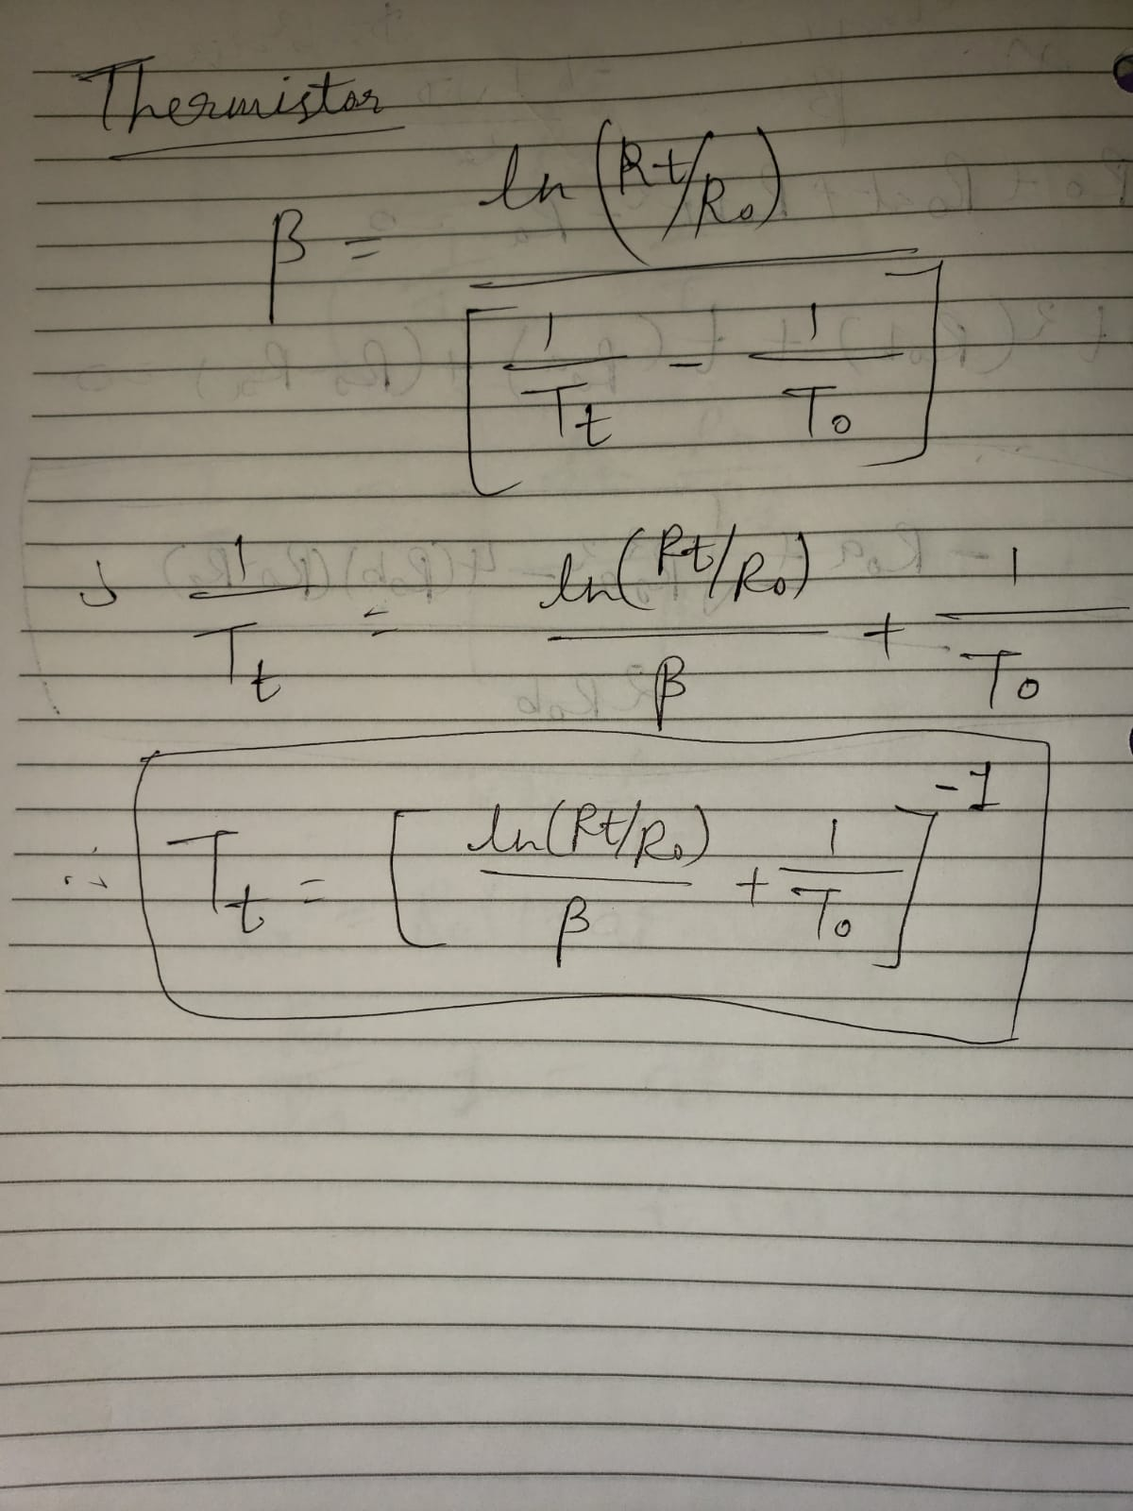



1. You are deciding between using a thermistor or a class A RTD for measuring the temperature of a critical circuit board of a smart phone near 25°C. The accuracy must be within 0.25°C throughout the range of measurement. Neither speed of response nor component cost is an issue.

What type of sensor do you use and why? Find an example online of a sensor that you could use for this application.

Answer: I will like to use a Thermistor for the above application due to certain reasons. First is that RTDs are more suitable for applications where a large range of operating temperature is required. For smartphones, range of operation is quite narrow – and thermistors are best for such use cases, where sensitivity is high, and range of operation is not so wide. Also, according to my search, RTDs are generally bigger in size, and consume more power. This can be observed [here](http://www.littelfuse.com/~/media/electronics/datasheets/leaded_rtds/littelfuse_leaded_rtds_thin_film_platinum_rtd_sensors_ppg_datasheet.pdf.pdf). That makes them inefficient choice for a smartphone. On the other hand, there are variety of thermistors that can be easily integrated on to a critical circuit board, inside a smartphone. This particular thermistor - [**MC65F103A**](http://www.mouser.com/ds/2/18/AAS-920-306C-NTC-Type-65-Series-031314-web-850433.pdf) is having the sensitivity of 0.2°C at 25°C, maximum power consumption of 25mW, and diameter of 1.65mm – all of these makes it an ideal choice for the scenario described in the question.

1. A 100 ohm Class A RTD probe is calibrated at three points for extra precision, with a curve of RTD (T) = RTD0 (1 + AT +BT2 + CT3(T -100)) where:

RTD (T) = the RTD element’s resistance in ohms at temperature T

RTD0 = the RTD element’s resistance in ohms at 0°C

T = the RTD element’s temperature in °C

A = 3.9083 x 10-3 /°C

B = -5.775 x 10-7 /°C2

C = 0 if T >= 0°C

IF RTD(T) = 116.01 ohms, what is T?

Answer: **41.22°C** (another root for the equation is 6726.4°C which is not a practical solution)

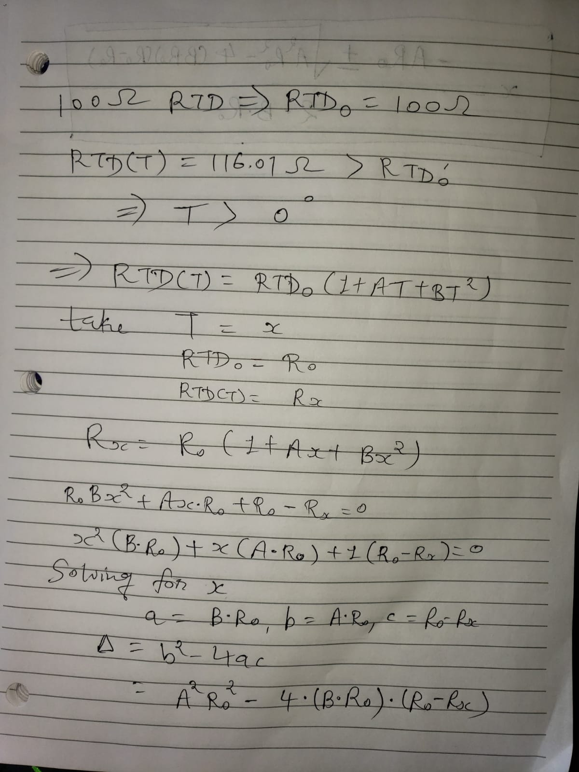

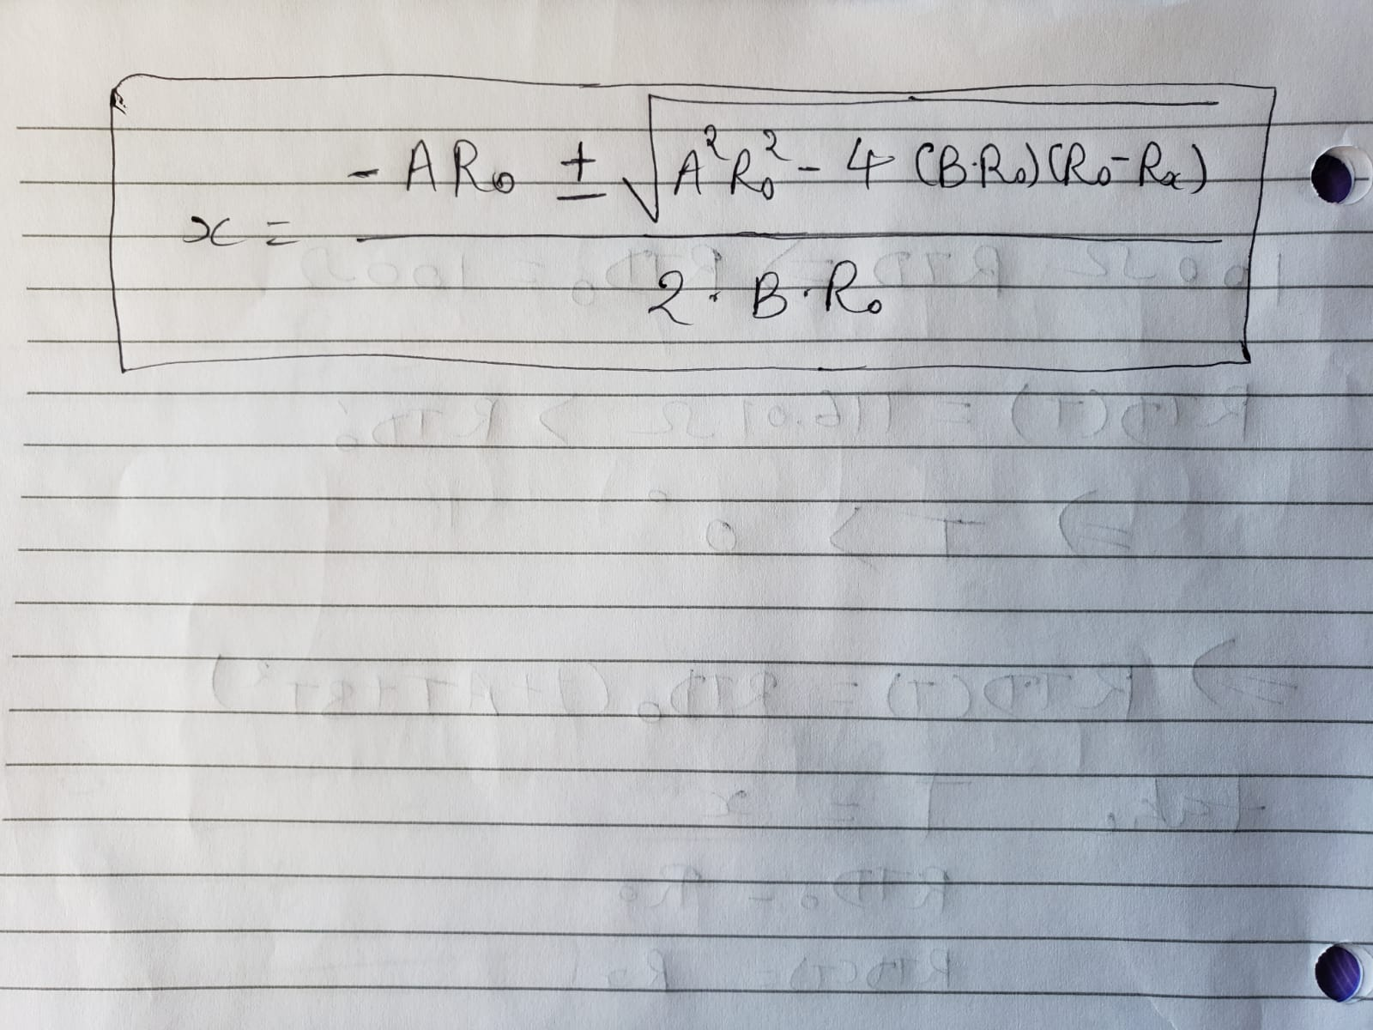

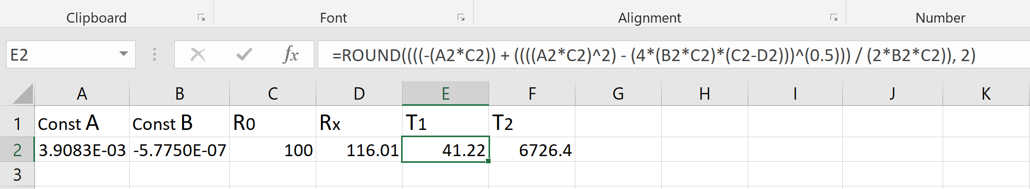

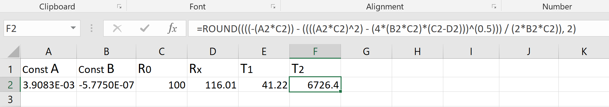

1. You are using a Type K thermocouple to measure the temperature of a process that operates in the range of 1000°C to 1100°C. In particular, you know that the thermoelectric voltage is 42.053 mV at 1020°C and 42.440 mV at 1030°C. Having no other data in between, and no way to look up the data on thermocouple tables, what is a good approximation for the thermoelectric voltage at 1027°C?

Answer: **42.446mV**

Thermocouples have almost linear relationship between temperature and voltage. Therefore, we can determine sensitivity (microvolts per Celsius degree) from given information, take the average, and multiply it with the given temperature (1027°C) to get an approximate value of the thermoelectric voltage.

Sensitivity 1 = (42053µV) / (1020°C) ≈ 41.22µV/°C

Sensitivity 2 = (42440µV) / (1030°C) ≈ 41.20µV/°C

Average Sensitivity ≈ 41.21µV/°C

Approximate Thermoelectric Voltage at 1027°C = (41.21µV/°C) * (1027 °C) = 42.446mV

1. You are using a Type K thermocouple to measure the temperature of a semiconductor etch process that operates in the range of 1000°C to 1100°C. The thermistor in your isothermal block (junctions J3 and J4) measures a temperature of 20°C and your voltmeter measures 44.240 mV. What is the temperature T1 of your process?

Answer: **1056°C**

First step is to convert thermistor temperature to equivalent thermocouple voltage. According to NIST table for [0°C to 300°C](https://srdata.nist.gov/its90/type_k/0to300.html), this voltage would be 0.798mV. Now we need to subtract this value from the measured voltage using voltmeter and convert that voltage to equivalent temperature using the sensitivity. Difference voltage = 44240µV - 798µV = 43442µV. Converting to temperature using the NIST table for [900°C to 1200°C](https://srdata.nist.gov/its90/type_k/900to1200.html), the temperature T1 of the process is 1056°C.

**F.** Suppose we include the lead resistance in the calculation of temperature for a class A RTD. If R3 = 1000 ohms, Ra = 20 ohms, V0 = 1.75 volts, and V = 5 volts, what is the nominal temperature measured. Given the tolerances, what is the highest temperature you could measure?

Answer: Nominal Temperature – **157.17°C** (another root for the equation is 6610.45°C which is not a practical solution). Highest Temperature – **157.63°C**

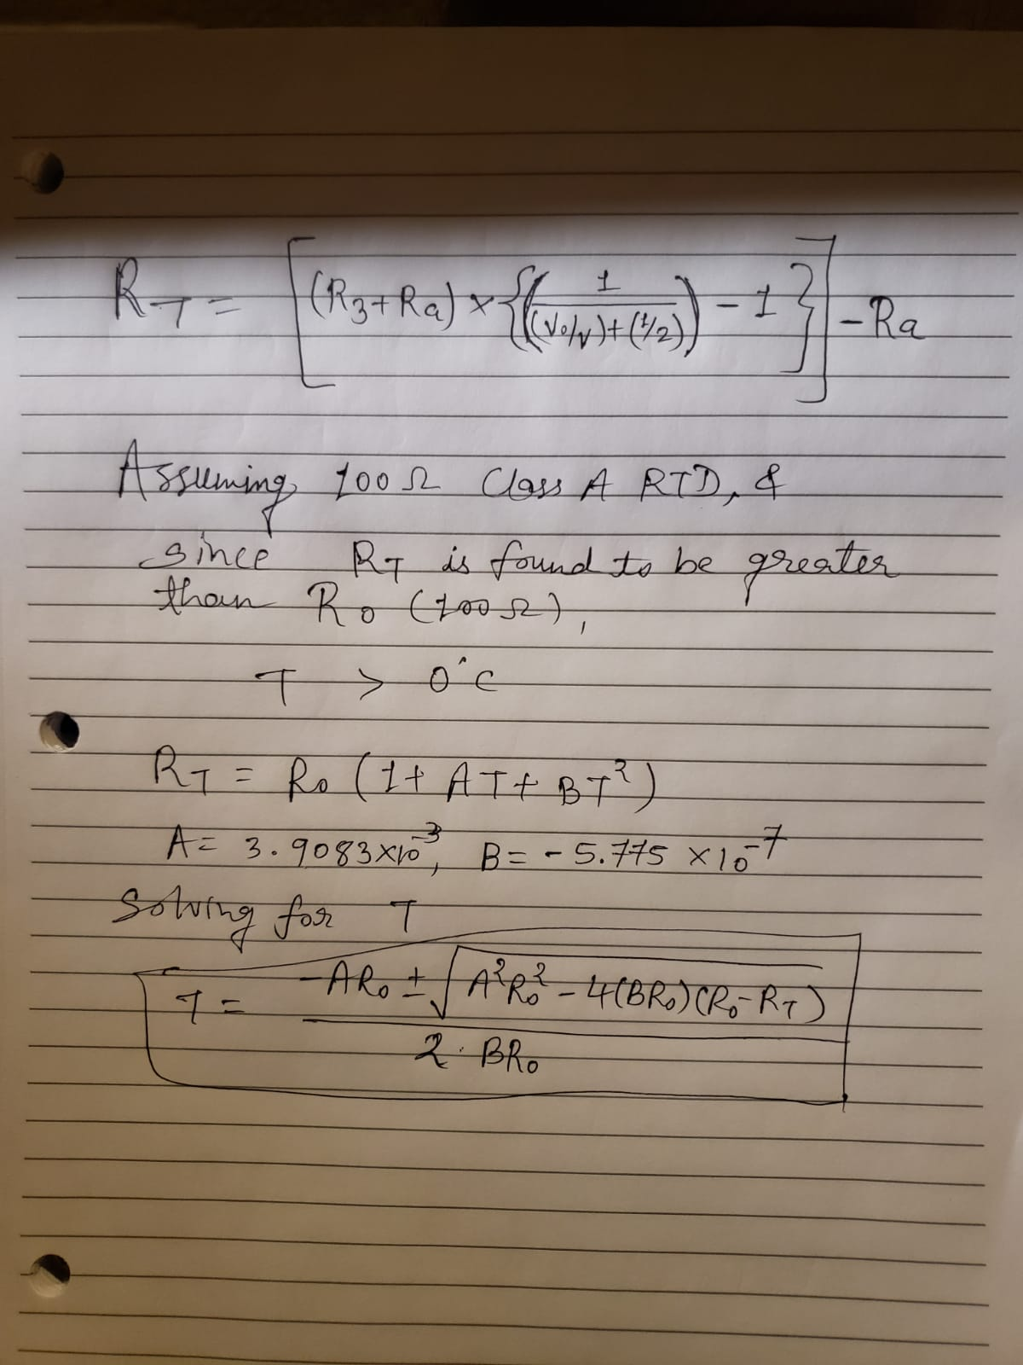

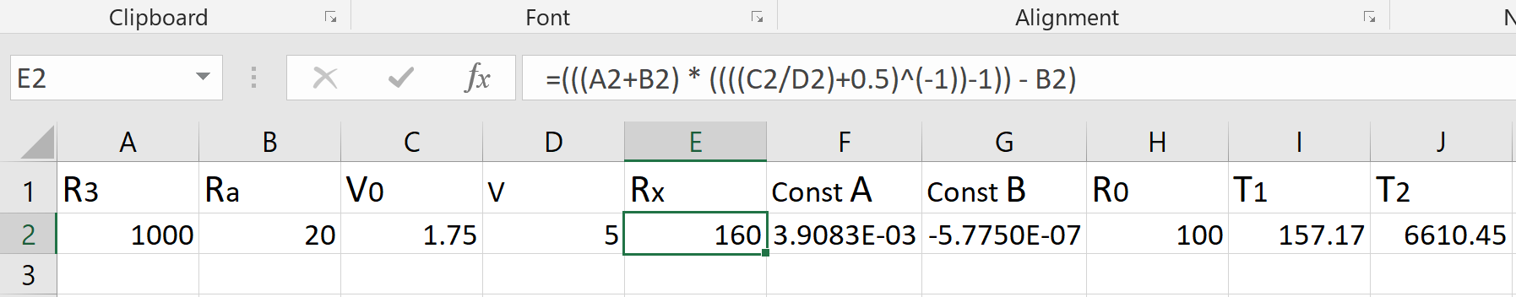

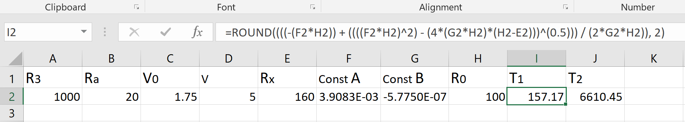

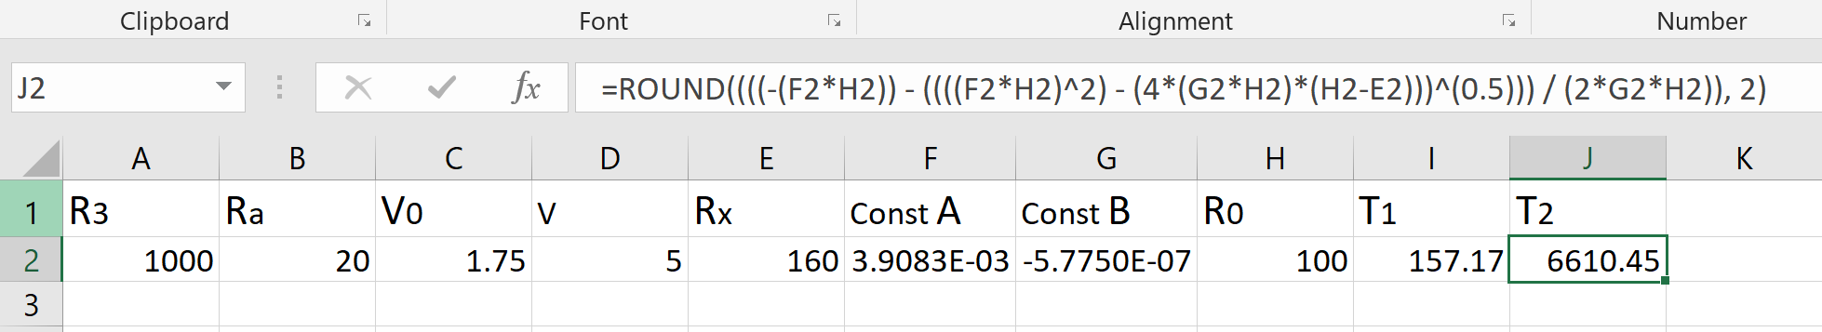

For 100Ω Type A RTD – temperature tolerance is ±(0.15 + 0.002 * T)°C. Thus the maximum temperature that could be measured for this nominal temperature would be – 157.17°C + (0.15 + 0.002 * (157.17°C)) = 157.63°C.

**G.** Why do we use a 3rd order polynomial to calibrate an RTD below 0°C, but only a 2nd order polynomial to calibrate an RTD above 0°C?

Answer: [[Source for this answer]](https://www.newport.com/medias/sys_master/images/images/h4b/h16/8797291446302/TN-RTD-1-Callendar-Van-Dusen-Equation-and-RTD-Temperature-Sensors.pdf)

The correlation between the resistance and temperature of the RTD is described by the Callendar-Van Dusen equation, which as per the follows:

**RT = R0 [1 + A*T + B*T2 – (T – 100)*C*T3]**

RT is resistance of RTD at the temperature T

R0 is resistance of RTD at 0°C

The A, B, and C are called Callendar-Van Dusen constants and their values are given by following equations:

**A= α + ((α*δ) / 100)**

**B= – ((α*δ) / 1002)**

**C = – ((α*β) / 1004)**

α, β, and δ are the constants which are found using following equations

**α = (R100 – R0) / (100 + R0)**

**δ = ([R0*{1 + (α*260)}] – R200) / (4.16*α*R0)**

**β can be only found empirically and is constant at temperatures less than 0°C; however for temperatures greater than 0°C, it is found to be 0. As per the equation of Callendar-Van Dusen constant C, it also becomes 0. Therefore, for temperatures higher than 0°C, the equation reduces from 3rd order polynomial to 2nd order polynomial.**

**H.** You are deciding between using a type K thermocouple or Class A RTD for measuring the temperature of steam between 250°C to 500°C. The accuracy must be within 2.5°C throughout the range of measurement. Your acceptable speed of response is 2 seconds. What type of sensor do you use?

Answer: According to IEC 60751:2008 [[1]](https://www.omega.com/Temperature/pdf/RTDSpecs_Ref.pdf)[[2]](https://reotemp.com/wp-content/uploads/2015/11/TBRTDTOL-0614RTDToleranceClasses.pdf)standard classes, the maximum temperature that can be measured for Type A RTD is 300°C. Moreover, RTDs have slower response time than Thermocouples, often longer than required 2 seconds [[3]](https://www.omega.co.uk/temperature/z/thermocouple-RTD.html)[[4]](https://www.thermo-electra.com/en/producten/technische-informatie/response-times)[[5]](https://www.isa.org/standards-and-publications/isa-publications/intech-magazine/automation-basics/thermocouples-versus-rtds/)[[6]](https://www.acromag.com/sites/default/files/Comparison_of_Thermocouple_and_RTD_Temperature_Sensors_918A.pdf). A quick look at [this](https://www.heraeus.com/media/media/group/doc_group/products_1/hst/m_sensors/us_3/M222_HST-USA.pdf) Class A RTD found from Digikey shows that it is having air response time of 3 seconds – which is not acceptable for the given application, and also the operation range is only up to 300°C. However, a Type K Thermocouple satisfies everything – accuracy of 2°C[[7]](https://en.wikipedia.org/wiki/Thermocouple) at 500°C, and even better (1°C) at 250°C; response times easily staying under 2 seconds[[8]](https://www.omega.com/techref/ThermocoupleResponseTime.html). Therefore, I would use Type K Thermocouple for this particular application.

1. In our explanation of how thermocouples work we added a copper lead wire at junction J2 in our thermocouple circuit for a type T thermocouple.

Why did we do this?

Answer: If we connect voltmeter with a simple thermocouple, then it will create an additional junction when copper leads of voltmeter joins the lead of thermocouple lead made up from another material (carbon in this case), and thus, it would result in a faulty reading on the voltmeter. Thus, to avoid this case, we create a Cu-C junction called J2 in type T thermocouple. This way, we can avoid the error (provided that we know the temperature at J2). To conclude, to avoid generating back emf of unknown value on the primary (sensing) junction – we added a copper lead wire at the junction J2.

1. In our explanation for how people originally used Type T thermocouples, why did they put junction J2 in a bucket of ice?

Answer: To find the temperature at J1 (primary/sensing junction), we must be knowing the temperature at junction J2. While we can use any known reference temperature for this to work, using anything else than 0°C will just increase the amount of calculation. However, in the case of putting J2 at 0°C, we are cancelling the second term in the thermocouple equation (to find T using V), which originated from the need of converting °C to °K.

1. A type K thermocouple datalogger uses a thermistor to measure the cold junction temperature. It has a resistance of 2252Ω at 25.0 °C, with β = 3630, and with a tolerance of +/- 0.2°C. You measure a resistance of 1120 ohms.

The voltmeter in the datalogger measures 48.395 mili volts. Given the tolerances for the thermistor and thermocouple, what is the highest temperature that the datalogger would read in °C?

Answer: **1150°C**



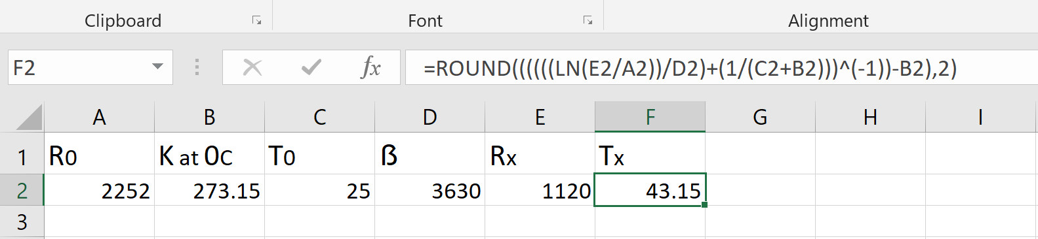

The thermistor is at the temperature of 43.15°C with 0 error. But it has a tolerance of ±0.2°C, and since we need the maximum temperature at the primary junction, we would need to take the lowest possible value of temperature at isothermal block/colder junction. That would be 43.15°C – 0.2°C = 42.95°C. Using the NIST lookup table for [0°C to 300°C](https://srdata.nist.gov/its90/type_k/0to300.html), and taking the reading for 43.0°C (error of 0.05°C), we get thermocouple voltage at isothermal block of – 1.735mV magnitude. The difference voltage (the actual voltage at the primary junction) is 48.395mV – 1.735mV = 46.660mV. Converting this to temperature using NIST lookup table for [900°C to 1200°C](https://srdata.nist.gov/its90/type_k/900to1200.html), we get 1141°C. Now, as the K Type Thermocouple has the temperature tolerance of [±0.0075*T](https://en.wikipedia.org/wiki/Thermocouple), the highest temperature that the datalogger would read is – 1141°C + (0.0075 * 1141°C) = 1149.55°C ≈ 1150°C.

1. Go to Google Patents ([www.patents.google.com](http://www.patents.google.com)) and download US patent 6,344,747. Read the patent and answer the following questions:

Q.1 In this patent why is the diagnostic element needed?

A.1. This patent aims to monitor the condition of a thermocouple over a long period of time, and compare different states at different times – to calculate the amount of deformation. For this, something had to be added in a thermocouple, in such a way, that measurements can be done accurately. Also, the evaluation of thermoelements in a thermocouple – should be able to done, while that thermocouple itself in use. There are two embodiments for this – (1) A thermocouple with two or more thermoelements is having multiple diagnostic elements connected at the common junction point; (2) A thermocouple is having only a single diagnostic element. In both of these though, a diagnostic element connected with a thermoelement – form a measurement loop; around which, a resistance or impedance measurement could be achieved.

Q.2 What is the main feature required for the diagnostic element?

A.2 The primary feature which is required for the diagnostic element is that at the expected operating temperature range of the thermocouple, the diagnostic elements are more stable than the thermoelements themselves are. Also, it is preferred if the diagnostic element is lesser prone to change in the resistance, under operational stresses, than the thermoelement(s) its being couple with.

Q.3 How is the diagnostic element connected into the thermocouple circuitry?

A.3 Diagnostic element is connected to a thermoelement, by welding it to the common junction of the thermocouple (and all thermoelements). This way, it makes a measurement loop around which – resistance or impedance can be measured easily.

Q.4 What are two reasons the patent says that thermocouples degrade over time?

A.4 Thermocouples degrade over time primarily because of the various resistance-altering stressed they’re exposed to during their life of operation. As thermocouples are exposed to wide temperature changes, the metals used in the sensor experience a number of cycles of resistance change. Eventually, the metals are exhausted and therefore, their resistance moves permanently.

Thermocouples are made up of two or more thermoelements, by connecting them together. Besides manufacturing impurities, the thermoelements could have impurities while being used by certain industrial application. This also causes resistance altering stress, and as thermoelements degrade over time, thermocouples start malfunctioning.

Q.5 Why can the diagnostic elements be used to detect changes in the resistance of the thermocouple wires?

A.5 Patent suggests that in the preferred scenario, the diagnostic element is more stable than the thermoelement with which it is being connected. Due to this, diagnostic element degrade much slower than the thermoelement – thus we can rely on the measurements made using diagnostic element – a long time ago, without much problem. So, when a thermocouple is new, its responses are recorded using diagnostic element(s), and after a long period of time, it can be recorded again and compared to the older records. This way, we can detect the changes in the resistance of the thermocouple wires.